**Explain the running modes of pig:**

**Execution Modes**

Pig has two execution modes or execution types:

* **Local Mode** - To run Pig in local mode, you need access to a single machine; all files are installed and run using your local host and file system. Specify local mode using the -x flag (pig -x local). Note that local mode does not support parallel mapper execution with Hadoop 0.20.x and 1.0.0. This is because the LocalJobRunner of these Hadoop versions is not thread-safe.
* **Mapreduce Mode** - To run Pig in mapreduce mode, you need access to a Hadoop cluster and HDFS installation. Mapreduce mode is the default mode; you can, *but don't need to*, specify it using the -x flag (pig OR pig -x mapreduce).

**Sample file for word count:**



**Pig script for word count:**

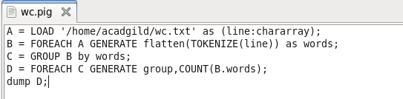

**Using Pig(Yarn)**

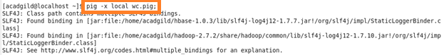

Inference: task completed in 10.928 seconds



**Using Tez**

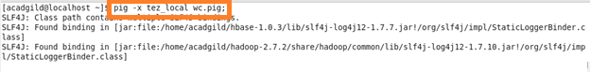

Inference: task completed in 5.343 seconds

